ACCOMMODATION RESERVATION FORM FOR participants:
ISHM2020
In Period: 24th – 28th August 2020

- 4 stars Superior hotel and Q-Latvia quality certificate.
- 222 guestrooms of different categories (Standard, Business class).
- Free of charge parking, with plentiful space for both groups arriving by bus/coach and for individual guests coming by car.
- The hotel is located next to one of the largest parks of Riga, Victory (Uzvaras) park.
- 8 conference halls with total area of 1200m² for congresses, business meetings, banquets etc.
- 11th floor panorama restaurant Le Sommet with a summer terrace, Park restaurant with a summer terrace, Lobby bar, SPA area(sauna, steam bath and Jacuzzi), massage salon, beauty salon, souvenir shop.
- Free of charge WiFi and Fitness room is available for guest needs.
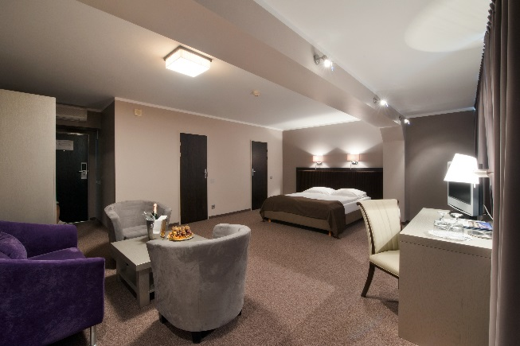
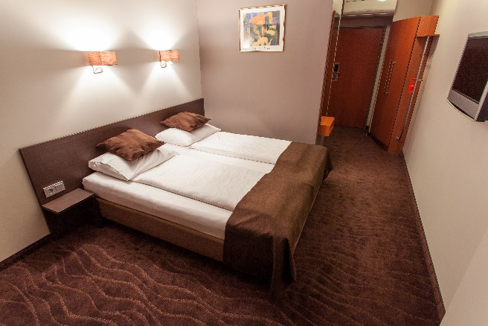
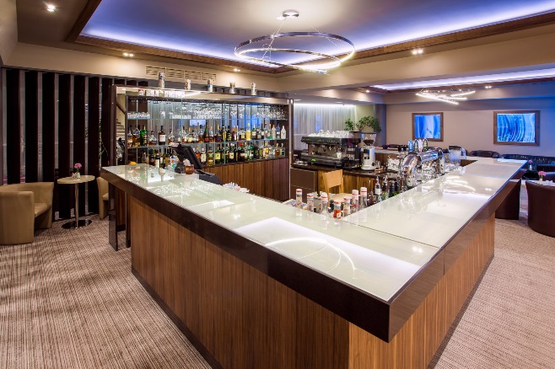
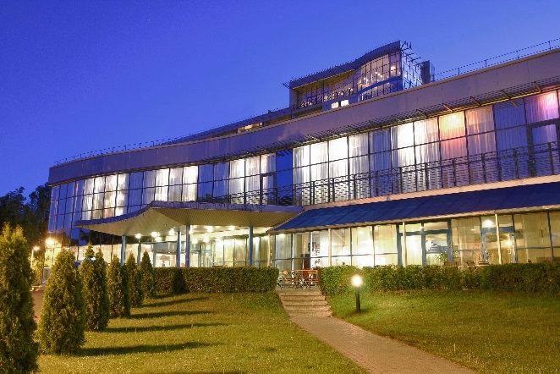

GUEST RESERVATION FORM
Guest Surname

Guest Name

Arrival date

Departure date

Room category: | Single occupancy/per night | Number of rooms | Twin/Double occupancy/ per night | Number of rooms
Standard | 60.00 EUR |  | 65.00 EUR
Superior | 75.00 EUR |  | 80.00 EUR
Apartment | 90.00 EUR |  | 100.00 EUR
Deluxe | 130.00 EUR |  | 130.00 EUR
The above rates are per room per night and inclusive: hot and cold breakfast buffet, free 24h access to gym, free WiFi, VAT.
E-mail address and phone number

Special requests

All rooms are equipped with: bath or shower, hair dryer, bathroom toiletries, WiFi Internet, satellite TV, telephone, mini bar, air conditioner, safe in room, coffee & tea facilities, iron & ironing board upon request in room.

Extra beds are available in Apartment rooms. Charge for extra bed 20.00 EUR/night. Please request when making the booking.

RESERVATION TERMS AND CONDITIONS

Please note that registration will be upon availability until the day of the Event. We kindly ask you to send this form by e-mail to reservations@bellevue.lv or call +371 67069053. After we receive your application, we will send you confirmation for your booking.

Guest credit card details are required to guarantee the reservation. Please enter your card details here: https://www.hotelbellevue.lv/form/ The card will not be charged prior to your arrival and is required only to guarantee your booking. Guaranteed booking is valid until 24:00hrs on arrival day.

The Customer shall be obligate to make all cancellations in written form by fax or e-mail. The cancellation shall be confirmed by the Hotel also in written form by fax or e-mail.

For individual travellers (1-5 persons):
Your reservation can be cancelled without any charge until 48 h before the arrival day. We trust in your understanding that in case of a no-show or a late cancellation we will charge your credit card for 100% of the first night stay.

For small groups (6-14 persons):
Your reservation can be cancelled without any charge 7 days before the arrival date.
We trust in your understanding that in case of a no-show or a late cancellation we will charge your credit card for 100% of the first night stay.

For group bookings the cancellation rules are as follows:
In case of cancellation of whole group 15- 50 persons:
- 30 days prior to arrival: free of charge,
- 15-29 days prior to arrival: 30% of arrangement rate,
- 8-14 days prior to arrival: 65% of arrangement rate,
- less than 8 days prior to arrival: 100% of arrangement rate.
50% payment 30 days before arrival date and other 50% 10 days before arrival date.
Should the amount of the booked rooms be reduced later than 7 days before the arrival date of the group, the Customer has to pay 1st night of the booking in accordance with the above mentioned prices.
In case of no-show 100% of arrangement rate will be charged for the 1st night.
We are looking forward to welcoming you at Bellevue Park Hotel Riga and we hope you will enjoy your stay!
www.hotelbellevue.lv

